HEALTHCARE DATA ANALYSIS FINAL REPORT

HEALTHCARE DATA ANALYSIS USING PYTHON
Minor Project Report
Submitted By
Name:Bonagiri geetha
College Name:CMR Technical campus(Autonomous engineering)
Internship Organization:SkillHigh
Department:CSE(Data science)
Academic Year: 2025-2026

ABSTRACT
Healthcare Data Analysis is an important field that helps healthcare organizations extract meaningful insights from large volumes of patient data. The objective of this project is to analyze diabetes-related healthcare data and identify significant health patterns and risk factors associated with diabetes. The dataset contains patient information such as glucose level, blood pressure, insulin level, body mass index (BMI), age, pregnancies, and diabetes outcome.
Python programming language and various data analysis libraries such as Pandas, NumPy, Matplotlib, and Seaborn were used to perform data preprocessing, exploratory data analysis, statistical analysis, and data visualization. The dataset was cleaned by handling invalid values and analyzed using different visualization techniques. Correlation analysis was performed to identify the factors most strongly associated with diabetes.
The results revealed that glucose level, BMI, and age are the most significant factors influencing diabetes occurrence. The project demonstrates how healthcare data analytics can support healthcare professionals in understanding disease trends, improving diagnosis, and making data-driven decisions.

INTRODUCTION
Healthcare is one of the most important sectors in society. Every day, hospitals, clinics, laboratories, and healthcare organizations generate enormous amounts of patient data. This data contains valuable information that can be used to improve healthcare services, identify disease patterns, predict health risks, and support medical decision-making.
Healthcare Data Analysis is the process of collecting, cleaning, transforming, and analyzing healthcare data to extract useful insights. With the growth of digital healthcare systems, data analysis has become a crucial tool for healthcare providers and researchers.
Diabetes is a chronic disease that affects millions of people worldwide. It occurs when the body cannot properly regulate blood glucose levels. If left untreated, diabetes can lead to severe complications such as heart disease, kidney failure, vision loss, and nerve damage.
This project focuses on analyzing diabetes-related healthcare data using Python. Through statistical analysis and visualization techniques, the project aims to identify important factors associated with diabetes and provide meaningful insights into patient health conditions.

PROBLEM STATEMENT
Diabetes is one of the leading health challenges worldwide. Early detection and proper management of diabetes are essential for preventing severe health complications. Healthcare organizations collect large volumes of patient data, but manually analyzing this data is difficult and time-consuming.
There is a need for effective data analysis techniques that can process healthcare data efficiently and identify important factors contributing to diabetes. This project addresses this problem by analyzing patient healthcare records and discovering significant health patterns related to diabetes.

OBJECTIVES
The main objectives of this project are:
- To analyze diabetes-related healthcare data.
- To perform data cleaning and preprocessing.
- To identify important health factors associated with diabetes.
- To visualize healthcare trends using graphs and charts.
- To perform statistical and correlation analysis.
- To generate meaningful healthcare insights.
- To support data-driven healthcare decision-making.

NEED FOR THE PROJECT
Healthcare organizations generate vast amounts of patient data that often remain underutilized. Analyzing this data can help identify disease patterns and improve patient care.
The need for this project arises because:
- Diabetes is a rapidly growing global health problem.
- Early diagnosis can reduce health complications.
- Data analysis helps identify risk factors.
- Healthcare providers require data-driven insights.
- Medical researchers need efficient tools for healthcare analysis.
This project helps bridge the gap between raw healthcare data and meaningful healthcare insights.

SCOPE OF THE PROJECT
The scope of this project includes:
- Analysis of diabetes-related healthcare data.
- Data cleaning and preprocessing.
- Statistical analysis of patient attributes.
- Visualization of healthcare trends.
- Correlation analysis between medical attributes and diabetes occurrence.
- Generation of healthcare insights.
The project is limited to descriptive data analysis and does not include machine learning-based prediction models.

LITERATURE REVIEW
Healthcare analytics has become an important research area due to the increasing availability of digital healthcare data. Researchers have used data analysis techniques to identify disease trends, predict patient outcomes, and improve healthcare services.
Several studies have demonstrated that factors such as glucose level, BMI, age, blood pressure, and family history play a significant role in diabetes development. Data visualization and statistical analysis techniques help researchers understand these relationships more effectively.
Modern healthcare systems increasingly rely on data analytics and artificial intelligence to improve patient care and support clinical decision-making.

SYSTEM REQUIREMENTS

Hardware Requirements
- Processor: Intel Core i3 or above
- RAM: 4 GB or higher
- Hard Disk: 500 GB
- Keyboard and Mouse
- Monitor

Software Requirements
- Operating System: Windows 10/11
- Programming Language: Python
- Development Environment: Jupyter Notebook
- Libraries:
  - Pandas
  - NumPy
  - Matplotlib
  - Seaborn

TECHNOLOGIES USED

Python
Python is a powerful and easy-to-use programming language widely used in data science and healthcare analytics.

Pandas
Pandas is a Python library used for data manipulation and analysis.

NumPy
NumPy is used for numerical computations and mathematical operations.

Matplotlib
Matplotlib is used to create charts and visualizations.

Seaborn
Seaborn provides advanced statistical visualizations and graphical representations.

Jupyter Notebook
Jupyter Notebook is an interactive development environment used for coding, analysis, and visualization.

DATASET DESCRIPTION
The dataset contains 768 patient records and 9 attributes.
Attribute | Description
Pregnancies | Number of pregnancies
Glucose | Blood glucose level
BloodPressure | Blood pressure measurement
SkinThickness | Skin fold thickness
Insulin | Insulin level
BMI | Body Mass Index
DiabetesPedigreeFunction | Family history indicator
Age | Age of patient
Outcome | Diabetes status
Outcome Values:
- 0 = Non-Diabetic
- 1 = Diabetic
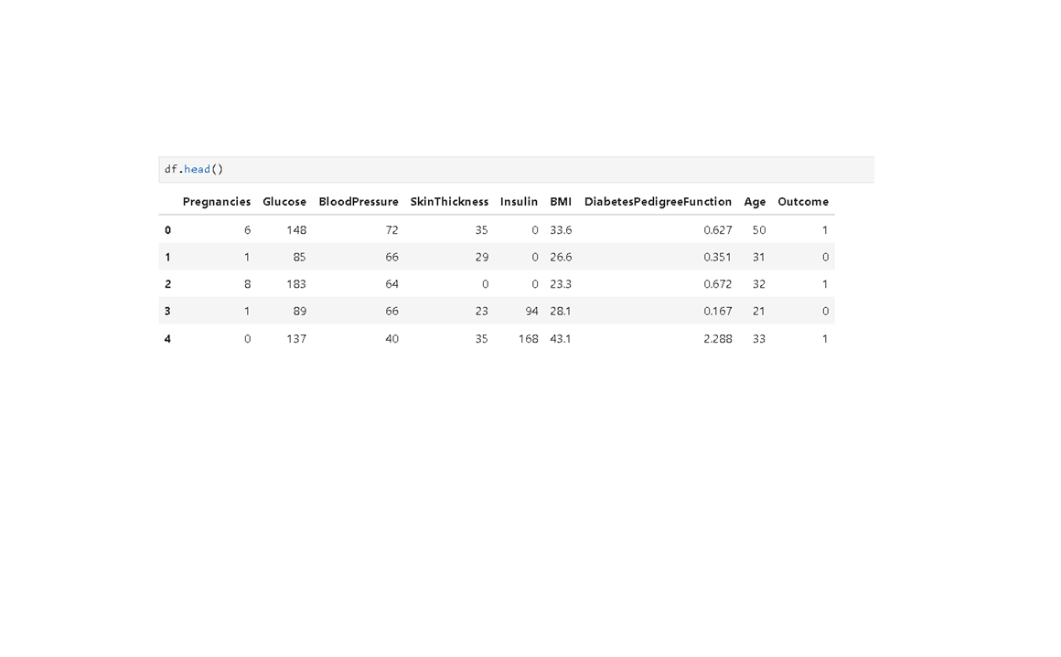

METHODOLOGY
The project was developed using the following methodology:
- Dataset Collection
- Data Loading
- Data Preprocessing
- Data Cleaning
- Exploratory Data Analysis
- Data Visualization
- Correlation Analysis
- Results Interpretation
- Conclusion

DATA PREPROCESSING
Data preprocessing is an essential step in healthcare analytics.
The following steps were performed:
- Loaded dataset into Pandas DataFrame.
- Examined dataset structure using df.info().
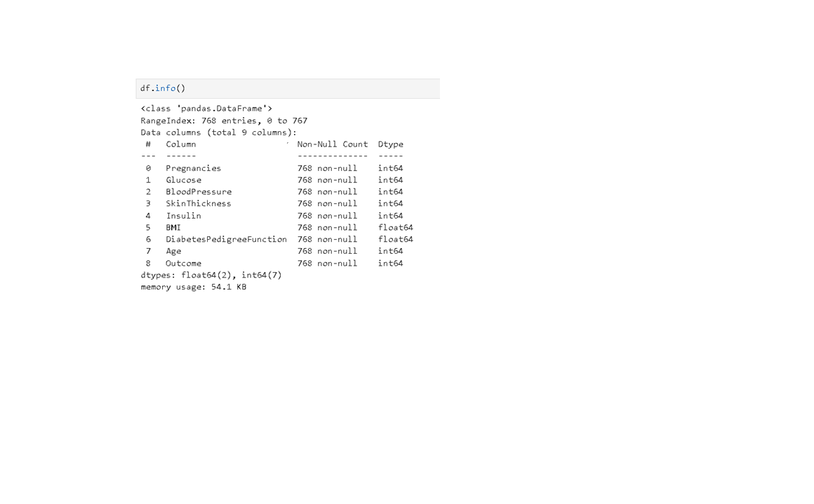
- Generated statistical summaries using df.describe().
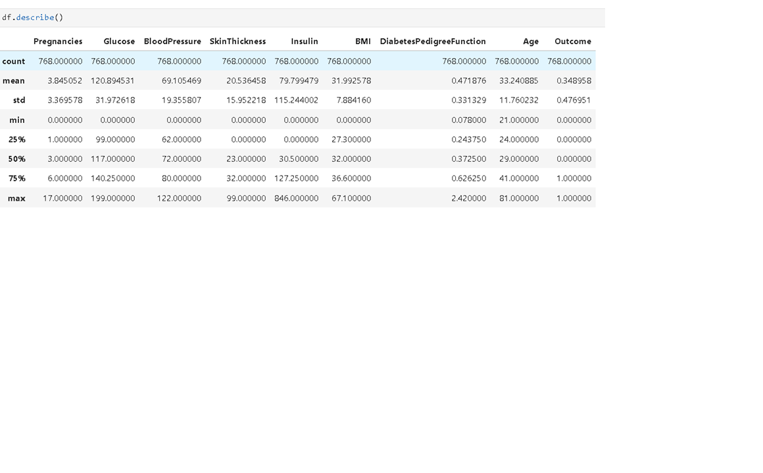
- Identified invalid zero values.
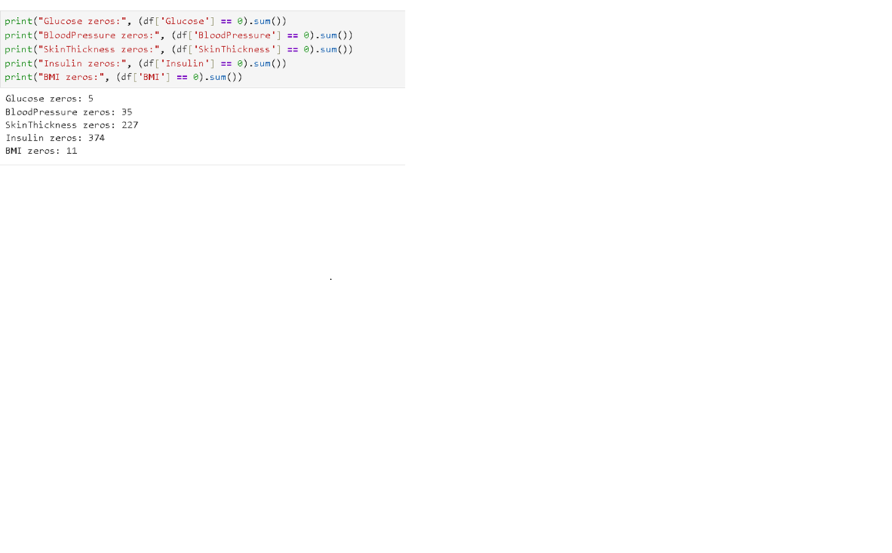
- Replaced invalid values using median values.
- Verified cleaned dataset.
Zero values found:
- Glucose = 5
- BloodPressure = 35
- SkinThickness = 227
- Insulin = 374
- BMI = 11
After preprocessing, all invalid values were successfully handled.
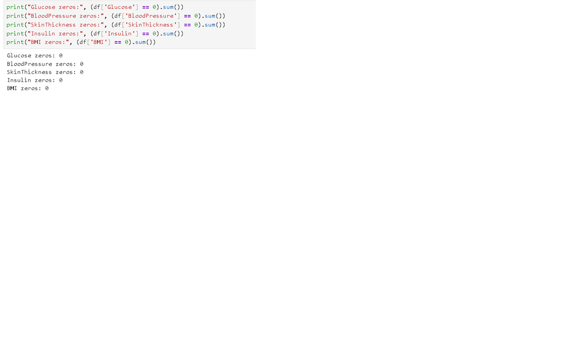

EXPLORATORY DATA ANALYSIS
Exploratory Data Analysis (EDA) was performed to understand the dataset and identify patterns.
The analysis included:
- Diabetes distribution analysis.
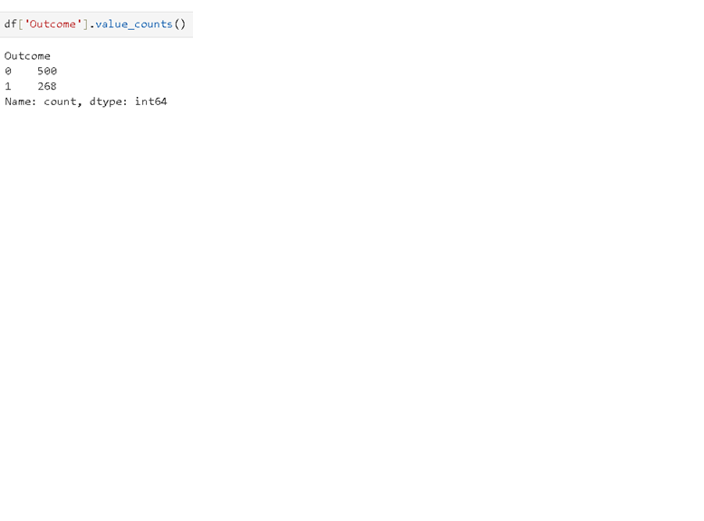
- Age distribution analysis.
- Glucose level distribution.
- BMI analysis.
- Correlation analysis.
- Average value comparison.
EDA helps transform raw healthcare data into meaningful information.

DATA VISUALIZATION
The following visualizations were created:
- Diabetes Distribution Bar Chart
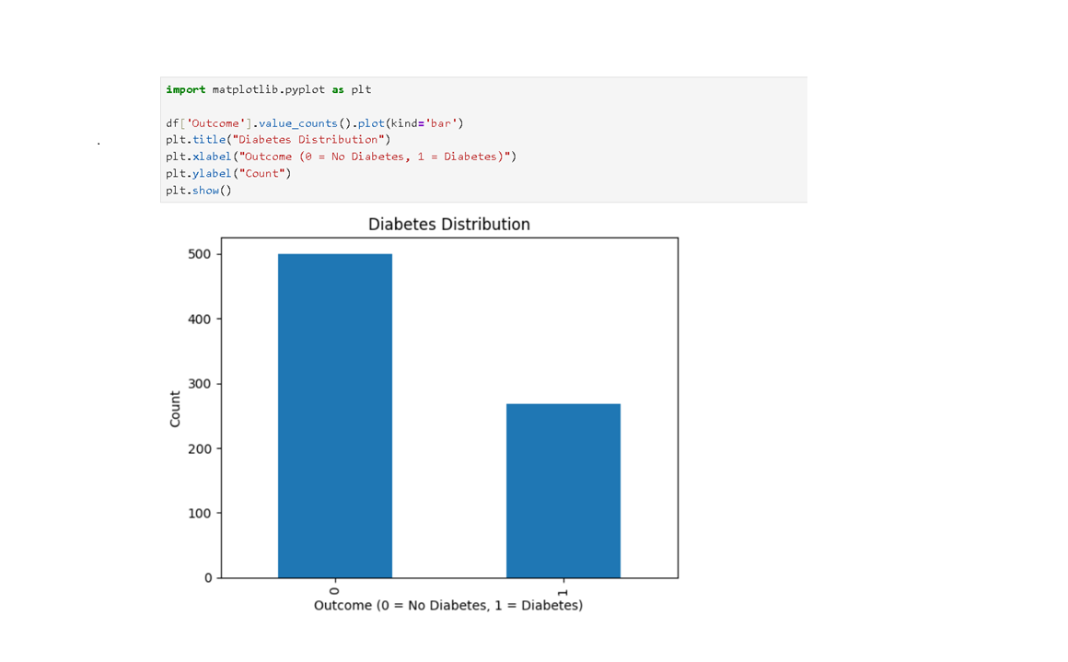
- Age Distribution Histogram
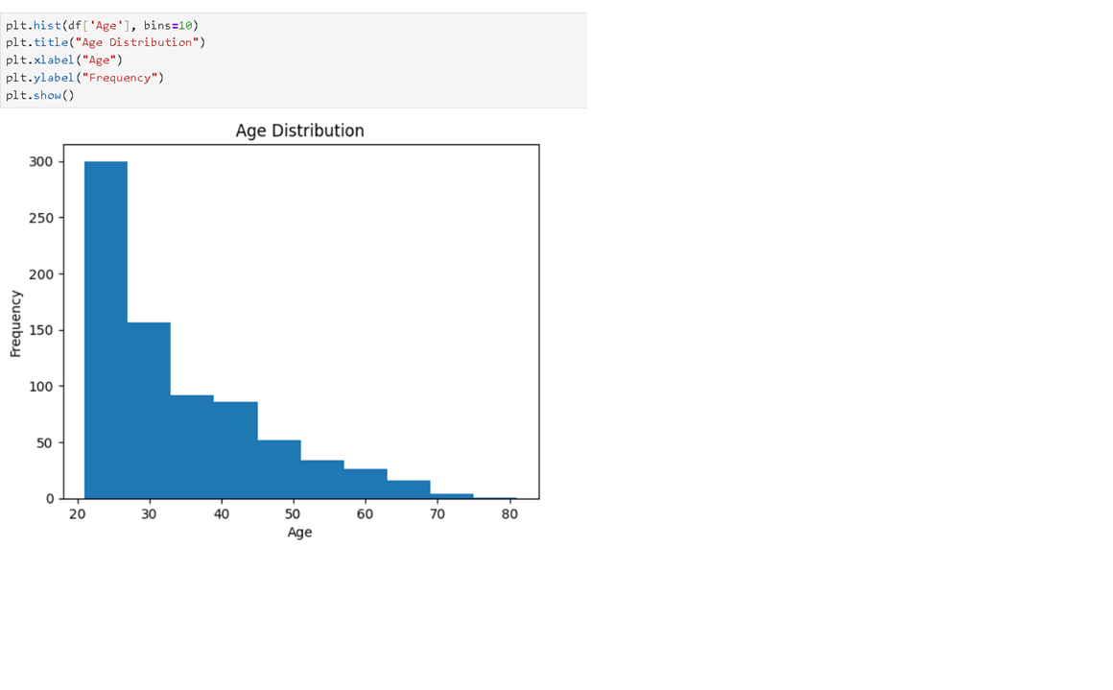
- Glucose Distribution Histogram
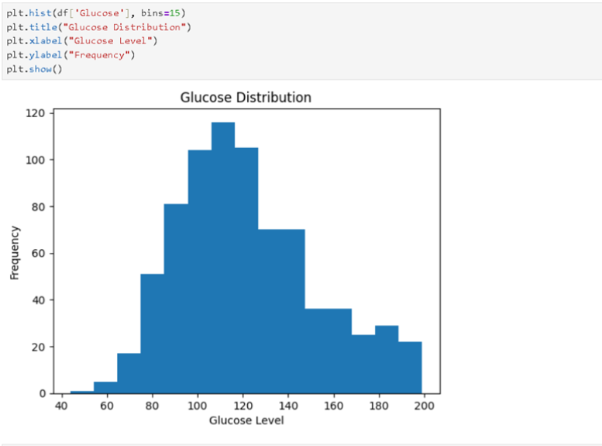
- Correlation Heatmap
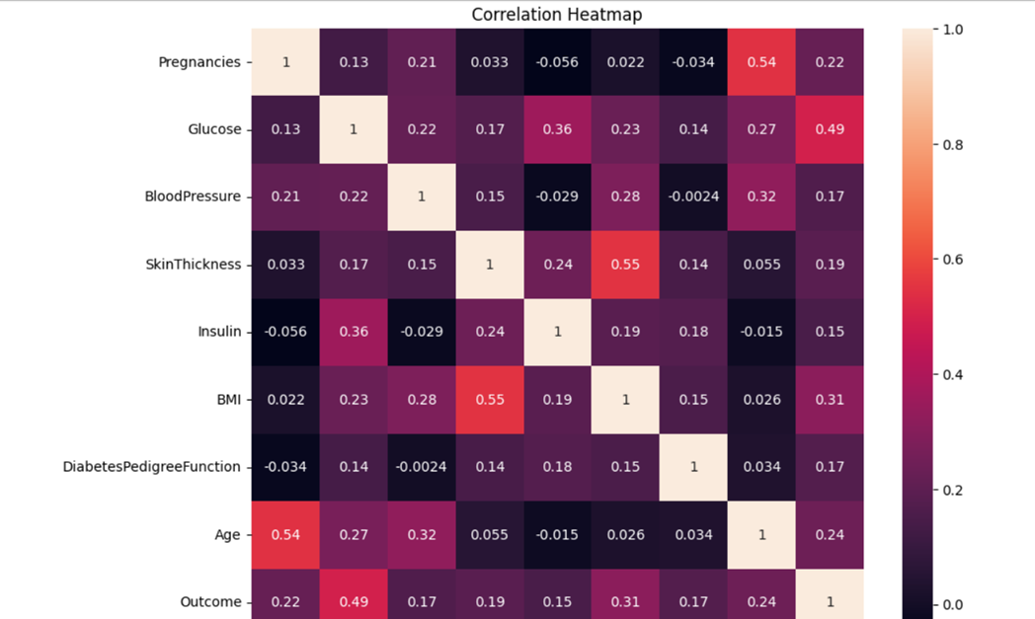
Visualizations provide an intuitive understanding of healthcare trends and patient characteristics.
- Glucose Levels by Diabetes Outcome
The box plot compares glucose levels between diabetic and non-diabetic patients. Patients with diabetes (Outcome = 1) have noticeably higher glucose levels than patients without diabetes (Outcome = 0). This observation supports the correlation analysis, which identified glucose as the most significant factor associated with diabetes occurrence.
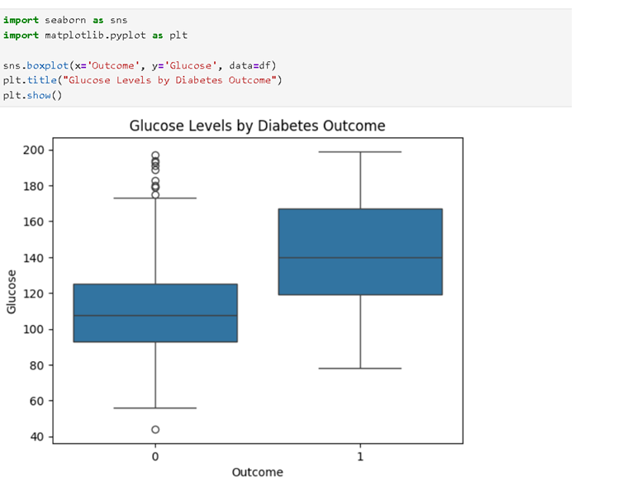

STATISTICAL ANALYSIS
Statistical analysis helps summarize the dataset.
Key measures include:
- Mean
- Median
- Standard Deviation
- Minimum Value
- Maximum Value
These measures provide information about patient characteristics and healthcare trends.

CORRELATION ANALYSIS
Correlation analysis was performed to identify relationships between attributes and diabetes occurrence.
Correlation Results:
- Glucose = 0.493
- BMI = 0.312
- Age = 0.238
- Pregnancies = 0.222
- SkinThickness = 0.189
- DiabetesPedigreeFunction = 0.174
- BloodPressure = 0.166
- Insulin = 0.148
The analysis shows that glucose level has the strongest relationship with diabetes.
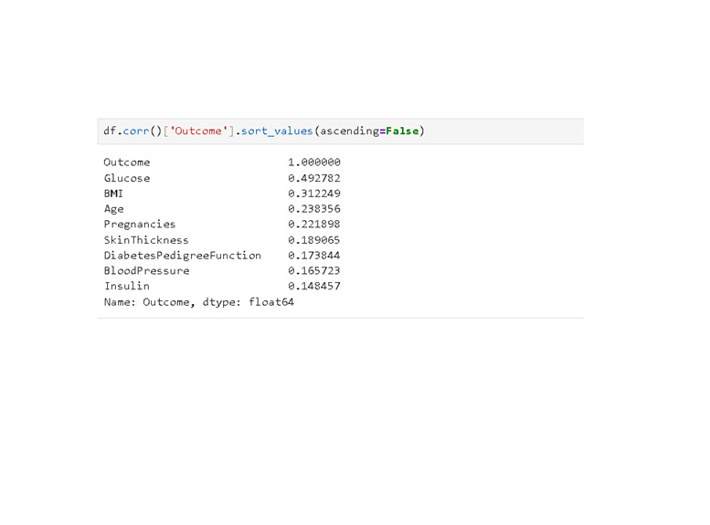

RESULTS AND FINDINGS
Average Values:
Non-Diabetic Patients:
- Glucose = 110.68
- BMI = 30.88
- Age = 31.19
Diabetic Patients:
- Glucose = 142.13
- BMI = 35.38
- Age = 37.07
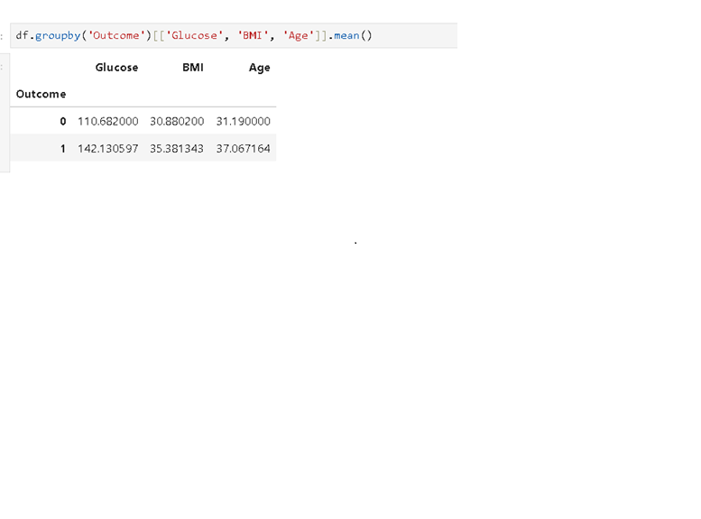
Key Findings:
- Glucose is the strongest indicator of diabetes.
- Higher BMI is associated with diabetes.
- Older individuals are more likely to develop diabetes.
- Multiple health factors influence diabetes occurrence.
- Correlation analysis confirms the significance of glucose, BMI, and age.

ADVANTAGES OF THE PROJECT
- Helps identify diabetes risk factors.
- Supports healthcare decision-making.
- Improves understanding of healthcare data.
- Demonstrates practical use of Python in healthcare.
- Provides meaningful healthcare insights.

LIMITATIONS OF THE PROJECT
- Analysis is limited to one dataset.
- Results may vary across populations.
- Does not include predictive machine learning models.
- Additional healthcare attributes could improve analysis.

APPLICATIONS
Healthcare Data Analysis can be applied in:
- Hospitals
- Clinics
- Medical Research Centers
- Public Health Organizations
- Health Insurance Companies
- Healthcare Technology Companies

CONCLUSION
The Healthcare Data Analysis project successfully analyzed diabetes patient data using Python. Data preprocessing, visualization, and statistical analysis techniques were used to identify important healthcare patterns and risk factors. The results showed that glucose level, BMI, and age are the most significant factors associated with diabetes occurrence.
The project demonstrates the value of healthcare analytics in improving disease understanding and supporting better healthcare decisions. Through data-driven analysis, healthcare providers can gain valuable insights into patient health and disease trends.

FUTURE SCOPE
Future enhancements may include:
- Diabetes prediction using Machine Learning.
- Development of healthcare dashboards.
- Real-time patient monitoring systems.
- Integration with cloud healthcare platforms.
- AI-based disease prediction models.
- Personalized healthcare recommendation systems.

REFERENCES
- Python Documentation
- Pandas Documentation
- NumPy Documentation
- Matplotlib Documentation
- Seaborn Documentation
- Diabetes Dataset Documentation
- Healthcare Analytics Research Papers

